Bighorn National Forest

Temporary Employment Guide for 2018
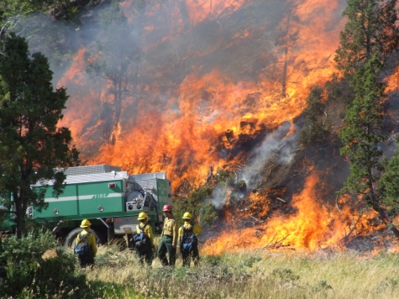 | 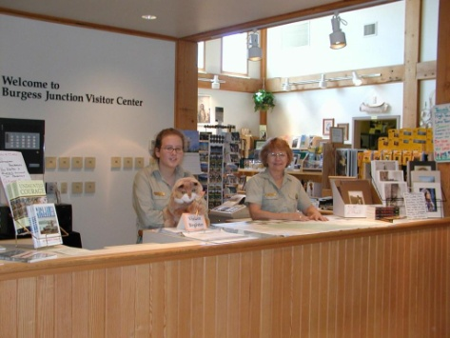 | 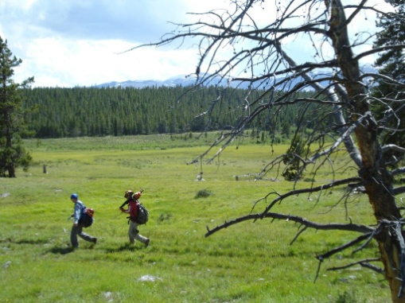
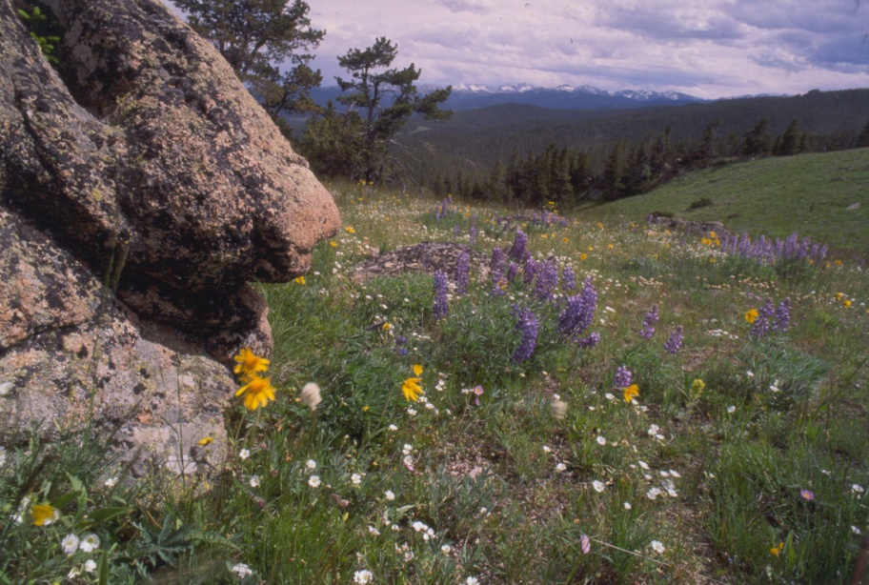
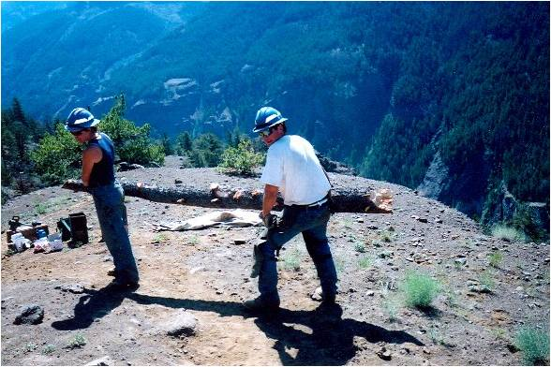 | 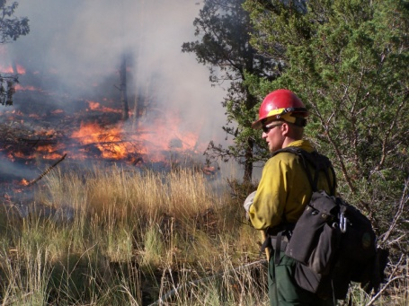 | 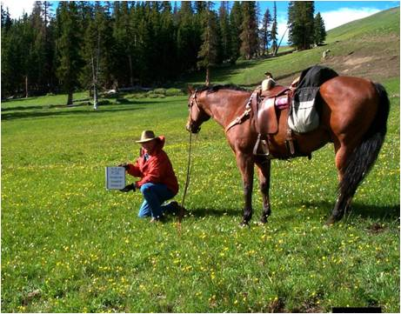

Powder River Ranger District  1415 Fort Street  Buffalo, WY 82834  Telephone 307.684.7806 | Medicine Wheel Ranger District  95 Highway 16/20  Greybull, WY 82426  Telephone 307.765.4435 | Supervisor’s Office  Tongue Ranger District  2013 Eastside 2nd Street  Sheridan, WY 82801  Telephone 307.674.2600


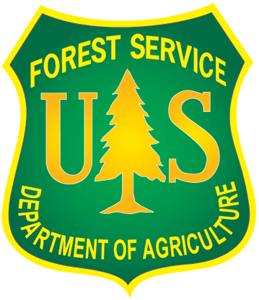
2018 Temporary/Seasonal Positions
USDA Forest Service, Rocky Mountain Region
Bighorn National Forest

The Bighorn National Forest is advertising and filling several temporary positions listed below for the following duty stations:

Powder River Ranger District, Buffalo, Wyoming
Medicine Wheel District, Greybull, Wyoming
Tongue Ranger District, Sheridan, Wyoming
Supervisor’s Office, Sheridan, Wyoming

This is a temporary employment outreach notice. The vacancy announcements will be posted on USAJOBS at www.usajobs.gov beginning on December 15th 2017 and can be accessed by the announcement number (Ann #). Announcement numbers are shown in this updated outreach notice as soon as they are available. They may also be obtained from the district offices or emailed to you if you complete the enclosed outreach response form. If numbers aren’t included in the title, the vacancy announcement has not yet been posted in USAJOBS. As USAJOBS is updated, this notice also will be updated. Please note the date of this notice shown at the bottom of the page. Job openings vary, beginning on December 15th 2017, and remaining open between 7 - 10 days only.
The Bighorn National Forest, created in 1897, is located in north-central Wyoming. The Forest is 80 miles long and 30 miles wide and covers 1,115,073 acres. It is located halfway between Mt. Rushmore and Yellowstone National Park. No region in Wyoming is provided with a more diverse landscape – from lush grasslands to alpine meadows, from crystal-clear lakes to glacially-carved valleys, from rolling hills to sheer mountain walls.

The Forest has multiple reservoirs, 30 campgrounds, four group campgrounds, three scenic byways, 10 picnic areas, eight lodges, miles of streams, 189,000 acres of wilderness, 1,500 miles of trails, and much more that provide a special recreation experience.

Some government housing is available.

Biological Science Technician – Fisheries GS-0404-05 $15.31/hr
Assists in the acquisition of field data by measuring and recording pertinent biological information particular to the specific assignment. Assists in the collection, handling, and preservation of specimens. Records all biological data pertinent to collections and preservation.

Hydrologic Technician- GS-1316-05 $15.31/hr
Develops, assembles, evaluates, adapts, and presents in tabular or graphic form, technical data in the fields of water data collection, stage data, stream discharge, rainfall, and wind gaging that includes special flow computations, current velocity analyses, flow and discharge estimations, and special data collection and study programs.

Biological Science Technician – Plants GS-0404-06 $17.06/hr
The biological science technician will for the summer field season support the plants/botany management program. This person will often work in the field independently or sometimes as a member of an aquatics team. Tasks will include surveys for rare plants within the forest, transect surveys in riparian areas to document plant species composition, computer data entry, and report preparation.

Biological Science Technician – Wildlife GS-0404-05 $15.31/hr
Crew leader to conduct field surveys for various terrestrial wildlife species, compile and report monitoring data, conduct wildlife habitat surveys and transects. Install and maintain various wildlife structures such as fences and water developments. The types of tools used to complete these tasks include maps, GPS units, cameras, and various hand tools. Individuals will receive training in the different types of survey methods.

Range Technician GS-0455-05 $15.31/hr
This is primarily a field position in support of the range program. Conducts vegetation inventories; livestock grazing use monitoring; and makes observations concerning livestock use, management, and structural improvements’ condition. Compiles monitoring information on various paper forms or electronic data collection devices. Maintenance of structural improvements such as fences and water developments.

Forestry Aid – Trails/Fire/Recreation GS-0462-03 $12.19/hr
Performs the full range of standardized forestry support duties for fire, timber, silviculture, recreation, wilderness, or research activities. Checks compliance with rules and regulations on parking, campfires, sanitation, use of picnic sites, or hunting and fishing; maintains and cleans up recreation/wilderness areas; performs standard fire prevention duties; or performs various standard duties related to silviculture activities.

Forestry Technician – Recreation GS-0462-04 $13.68/hr
Forestry Technician – Recreation GS-0462-05 $15.31/hr
Contacts visitors to provide information about recreation regulations, opportunities, and current restrictions. Provides information on resource management practices in the area. Checks for compliance with regulations, issues notices for common violations, and reports other violations to supervisor. Ensures recreation areas and trails are maintained in accordance with standards. Constructs and rehabilitates minor recreation facilities and trails. Makes safety checks of public use areas and takes corrective action.

Forestry Technician – Trails GS-0462-04 $13.68/hr
Leader or crew member in support of programs in recreation and wilderness management with the ability to hike long distances in a remote setting. Duties include maintaining and constructing trails, installing water bars, livestock guards, and/or bridges, using various tools and equipment. Performs trail log, condition surveys, trail clearing, and reconstruction. Patrols trails to ensure operation, use, and maintenance in accordance with standards. Uses tools such as chain saws, crosscut saws, adze, axes, and hand tools, and may operate ATVs, UTVs, 4X4 trucks and trailers.

Forestry Technician – Wilderness GS-0462-04 $13.68/hr
Forestry Technician – Wilderness GS-0462-05 $15.31/hr
Crew member for duties in support of programs in recreation and wilderness management with the ability to hike long distances in a remote setting. Duties include checking visitor use, monitoring compliance with agency rules and regulations for campfires, sanitation, camp sites, party size, etc., performs trail log, condition surveys, trail clearing. Uses tools such as crosscut saws, adze, axes, and hand tools to maintain wilderness areas and trails utilizing minimal tool concept. Assists in re-establishment of native plants at denuded campsites and abandoned trails, completes water quality sampling, provides wilderness education and Leave No Trace guidance to visitors.

Forestry Technician – Timber Sale Prep GS-0462-05 $15.31/hr
Acts as a certified timber cruiser. Independently applies the instructions issued in a cruise plan. Takes and records tree measurements, assesses quality, and determines defect. Prepares and computer processes cruise data. Participates in other aspects of resource management support work such as recreation, maintenance, silviculture, tree planting, etc.

Visitor Services Information Asst. GS-1001-04 $13.68/hr
Visitor Services Information Asst. GS-1001-05 $15.31/hr
This is a visitor services position located at the Medicine Wheel / Medicine Mountain National Historic Landmark. Employee must demonstrate ability to communicate with the public to disseminate information about national forest programs and sites.
Customer Service Representative GS-0303-03 $12.19/hr
Greets visitors and responds to phone and written inquiries to disseminate information about national forest programs and sites. Serves as collection officer to sell such items as visitor maps, Christmas tree permits, forest product sale permits, and Golden Age Passports.

Laborer WG-3503-03 $13.06/hr
The position performs a variety of manual labor using a variety of hand and/or power tools. Assignments often require heavy lifting (over 50 pounds) and strenuous physical effort, prolonged standing and walking, stooping and bending, climbing over uneven forest terrain and up steep slopes.

Maintenance Worker WG-4749-05 $15.80/hr
Performs various duties to accomplish preventive maintenance, repair, and upkeep of buildings and grounds. Operates heavy and light power equipment in a safety first manner. Assignments include but not limited to carpentry, painting, operation of tools and equipment, and general laborer tasks. Working knowledge of current plumbing and electrical practices necessary. The position often requires heavy lifting (over 50 pounds), and strenuous physical effort, prolonged standing and walking, stooping and bending, climbing over uneven forest terrain and up steep slopes. The ability to operate motor vehicles in performance of assigned duties required.

Engineering Equipment Operator WG-5716-08 $20.34/hr
Incumbent operates one or more types of heavy equipment, such as graders, tractors with bulldozer or angle dozer blades, front-end loaders, backhoes, trench diggers, and large industrial tractors with pan or scraper attachments. Work is generally on flat or rolling terrain with simple terrain problems, such as forest roads or compounds. Incumbent maintains ditches, road shoulders, and beds and fire lines and clears brush, tree stumps and rocks. Reviews the work to be performed and adjusts equipment attachments for a set level, angle,
or depth, according to the type of equipment used. Ensures equipment is maintained in good working condition.

Fire

CONDITIONS OF EMPLOYMENT – FIRE POSITIONS

Successfully complete the WORK CAPACITY TEST (WCT) for Wildland Firefighters. Based on the type of work performed, TAKING and PASSING the WCT at the ARDUOUS level is a “condition of employment.” The Arduous fitness (Pack) Test consists of a three (3) mile hike, within forty-five (45) minutes, while carrying a forty-five (45) pound pack.

These vacancies will not be extended. These are full time, seasonal positions that begin in late April and continue through the summer fire season. These positions may require considerable travel and irregular work hours. Most firefighters live at remote stations on the Bighorn National Forest, where they will serve as crew members on initial attack fire crews.

The Powder River Ranger District (Buffalo, WY) staffs one eight-person wildland fire module and one three- person engine module.

The Medicine Wheel Ranger District (Greybull, WY) staffs one five-person hand crew and one three-person engine module.

The Tongue Ranger District (Sheridan, WY) staffs one four-person hand crew and one four-person engine module.

The Medicine Wheel Ranger District (Greybull, WY) is home of the Wyoming Interagency Hotshots, a national firefighting resource hosted on the Bighorn National Forest.

Fire crews are responsible for initial attack fire suppression on their districts and assisting fire crews on adjoining districts. Fire assignments nationwide are possible through the fire season, so applicants must be willing to travel with the crew and be on assignments for up to 16 days. Other activities include fuels reduction projects, facility maintenance, prescribed fire, continuous training, and various other projects on the national forest.

Forestry Aid – Fire GS-0462-03 $12.19/hr
These positions are part of a wildland fire crew, performing firefighting work on an engine or hand crew. Assignments include developing a working knowledge of fire suppression and fuels management techniques, practices, and terminology. This consists of fireline construction, use of pumps and engines, hose lays, hand tools, chainsaws, working around aircraft, and patrolling fireline to locate and extinguish hotspots that may be a threat. Cleans and maintains fire tools and equipment. During prescribed burns, monitors and controls the fire, and collects data on fire weather and fire behavior. There may be frequent travel associated with these positions.

Forestry Technician – Fire Hand Crew, Engine GS-0462-04 $13.68/hr
Performs as a member on a wildland fire engine, hand crew, or hotshot crew assigned to suppress the full range of difficult and complex fires. Moves dirt, chops brush, fells small trees, etc., to build fireline using hand tools such as axe, Pulaski, shovel, McLeod, and power saws to control spreading wildland fire. Lays or directs hose in the use of water. Fells trees or snags using power saws. Sets backfires as directed. Cleans, reconditions, and stores specialized fire tools and equipment. Patrols areas of controlled fires to mop-up by searching out and extinguishing any remaining burning material. Operates specialized fire suppression equipment such as portable pumps or drip torches. Observes, records, and preserves evidence of cause of fires.

Forestry Technician – Hotshot Crew GS-0462-04 $13.68/hr
The Wyoming Hotshots, established in 1967, are a well-established crew with a long and rich history. The crew is funded to operate from the middle of May through the middle of October. The crew’s primary mission is to fight fire, ranging from initial attack to large fire support. The crew provides assistance to the Bighorn National Forest’s fire management program and the surrounding agencies in northern Wyoming and eastern Montana by assisting the prescribed fire programs.

Forestry Technician – Hotshot Crew GS-0462-05 $15.31/hr
The Wyoming Hotshots, established in 1967, are a well-established crew with a long and rich history. The crew is funded to operate from the middle of May through the middle of October. The crew’s primary mission is to fight fire, ranging from initial attack to large fire support. The crew provides assistance to the Bighorn National Forest’s fire management program and the surrounding agencies in northern Wyoming and eastern Montana by assisting the prescribed fire programs.

Forestry Technician – Hand Crew, Engine GS-0462-05 $15.31/hr
This position serves as a skilled crew member on a hand crew or Engine assigned to perform fire suppression duties under the most adverse conditions of climate, fuels, and terrain on the full range of complexity of fires. Performs the duties of a fully qualified chainsaw operator and chainsaw repair technician. Certified in the use of helicopter long lines. Performs all aspects of wildland and prescribed fire operations including preparation, ignition, monitoring, holding, and mop up. Collects fire weather data, fuel, and/or soil moisture samples, maps projects, and maintains records. May on occasion serve as driver of a crew carrier. Gathers and considers information on weather data, topography, fuel types, and fire behavior in responding to wildland fire incidents. This position requires frequent travel to all parts of the country to perform suppression activities.

Applicant Guide
These appointments are temporary seasonal positions. The vacancy announcements are posted on USAJOBS at www.usajobs.gov/.
To apply for a job, there are four basic steps:
- Create an account - Enter your profile information and create or upload a resume. Please note that you do not need to create a “My Account” to search for jobs, but you must create an account to apply for jobs online. You will need to request a user ID and password. Allow yourself at least two days before the application deadline to complete this process to ensure you have time to submit your application.
- Search Jobs – Use basic search to enter in job and location keyword information from the USAJOBS home page. Or you can use the advanced search function which allows you to search by vacancy announcement number or series and grade. Review the job opportunity announcements and note of those of interest. Carefully review the Qualification and Evaluation section to determine whether you will qualify for the position. GS-3 positions are entry level positions. As the grades get higher (GS-4, GS-5, etc.), they require more specialized experience or qualifications.
- Apply for Jobs – Carefully follow the instructions in the How to Apply section for each announcement. You may store up to five uploaded or resume builder-created resumes in your profile. Submit any additional documentation to verify your qualifications such as transcripts, SF-50 Notification of Personnel Action (if you have previously worked for the federal government), and/or Veterans’ Form DD-214. Please see the Additional Information below regarding supplemental documentation and resumes.
- Manage Your Career – Log into your account to obtain application status for positions for which you have applied. Contact the agency for specific follow-up questions or those related to the particular job. The agency contact information is listed on the right side of the announcement. You may also contact ranger district personnel regarding the position. However, please note that we do not see your application until the vacancy announcement has closed and we have requested a list of candidates. Only those applicants that are qualified for the position will be referred to the hiring official.
Additional Information
Regarding Applications:
- If you have experience as a firefighter, be sure to attach your IQCS, or IQS, Master Record to both your USAJOBS account and your application. This documentation supports what you are submitting in your application. Failure to attach it may disqualify you from being eligible for higher-graded fire positions, specifically at the GS-5 level or higher.

- If you are basing any of your qualifications on your education, you must attach valid transcripts. There is no method to verify education (including coursework completed and GPA) without these.
  - Special Notes:
    - Valid transcripts are those that are issued by the school (official or unofficial). Course listings/grades pulled from your student profile or account are not transcripts.
    - Transcripts that have been altered in any way (i.e. written on, edited) are not considered valid.
    - Attaching password protected transcripts is not recommended. There is not a remarks section within the application that will allow you to provide the password. If they cannot be accessed, they cannot be verified.
- If you are claiming veteran’s preference, you must attach your DD-214.
- It is important to remember that your answers to the minimum qualification – knowledge, skills, and abilities – questions must be supported by the contents of your resume or attached documents.

Regarding Resumes:
Your resume is the basis for determining qualifications, so it needs to be as complete as possible. There are a number of items that should be included to improve your chances of making the referral list and being selected for a seasonal/temporary position with the Forest Service.
Work Experience:
- Be sure to include specific dates of employment, in mo/day/yr format (e.g., 05/15/2012 – 08/24/2012), and hours per week. This helps determine experience level. Note: the resume builder in USAJOBS only allows you to select mo/yr. It is recommended that you upload your own resume or include the specific dates in the remarks section where you explain your work experience for that position.
- Be very specific and detailed when describing your work experience. Include everything: duties, responsibilities, equipment and tools used. It is important to remember that the people determining your qualifications are comparing your work experience to the position description of the job you are applying for. This is especially true for higher graded positions (GS-4, GS-5).
- Volunteer experience also counts. If you have volunteered for local organizations be sure to include it.

Certifications:
- Include all relevant certifications and training. For instance, if you are a certified pesticide applicator, this would be good to include on a resume for a weeds/range position. If you are applying for a fire position and have completed S-190 Introduction to Wildland Fire Behavior, document this on your resume.

References:
- References are checked during the selection process. Be sure to include at least two professional references.

2018 Temporary/Seasonal Employment
Bighorn National Forest
Outreach Response
Please indicate your interest by emailing a copy of this form by December 8, 2017, to:
Zane Macey, bmacey@fs.fed.us, P: (307) 674-2693

Name:
Email Address:
Phone Number: Work, Home or Mobile?

Location/Duty Station Preference:
Position(s) Interested In:

Experience that qualifies you for this position?

How did you hear about our temporary employment opportunities?
Agency Contact Other

If not a current permanent employee, are you eligible to be hired under any of the following special authorities?
_____ Schedule A
_____ VRA
_____ Veterans w/30% Compensable Disability
_____ Former Peace Corps Volunteer
_____ Pathways Program (Students and Recent Graduates)

